Smallest subsequence with sum k

Problem
Given an array a[] of size n. Your task is to find the smallest subsequence with sum of elements equal to k.

Example
Given an array of size 5,
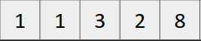
K = 12

Subsequences which satisfy the given condition are
, 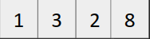, 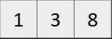, 
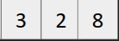

Subsequences with minimum length
, , 
Therefore answer = 3.

Approach
- Keep a MaxHeap and insert all the elements.
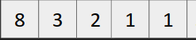
MaxHeap

- Keep popping the element and keep adding them to a variable sum and maintain their count
- When sum becomes greater than or equal to k, break the loop and output the cnt.
Time Complexity: O(nlog(n))

